Model 8: Force = c0 + c1(1-Erel)^2 + c2(P)

Description: Testing if (1-Erel)^2 term is good enough to shift plots to match data.

Note: slope of model shouldn’t be a big concern now since I have not added terms to change the slope.

|  |  |  |  |
| --- | --- | --- | --- |
|  | C0 | C1 | C2 |
| 10mm (P) | -366.9449 | 329.3102 | 0.6785 |
| 10mm (DP) | -300.6856 | 284.6008 | 0.5872 |
| 20mm (P) | -721.1431 | 748.7470 | 1.7610 |
| 20mm (DP) | -676.4303 | 574.5064 | 1.9615 |

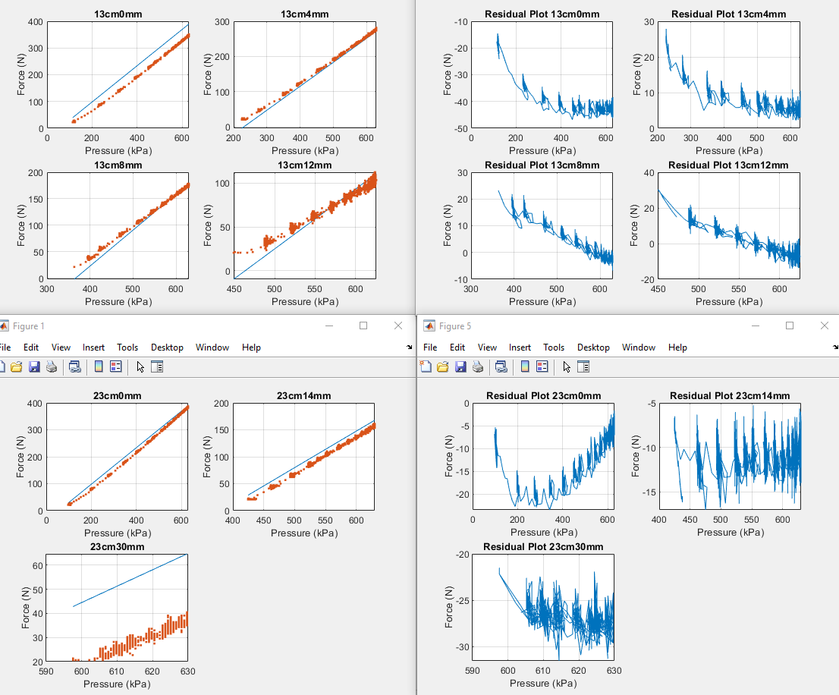**10mm(Pressurizing)**

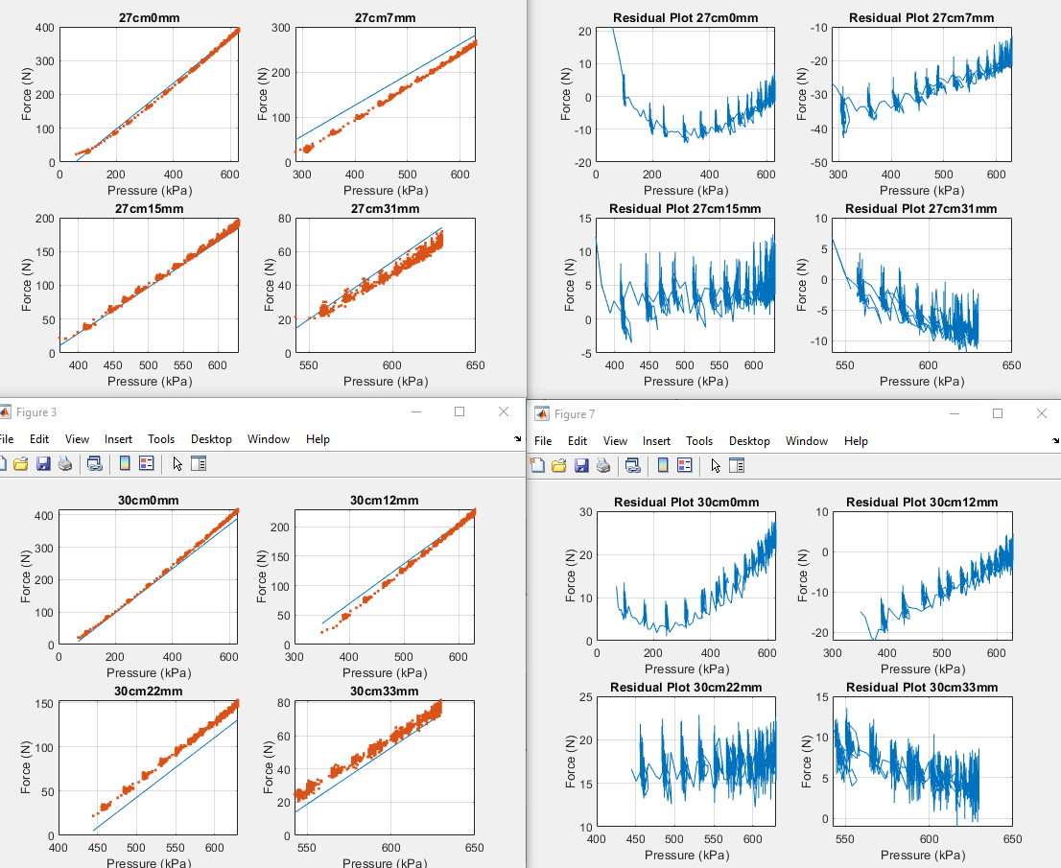

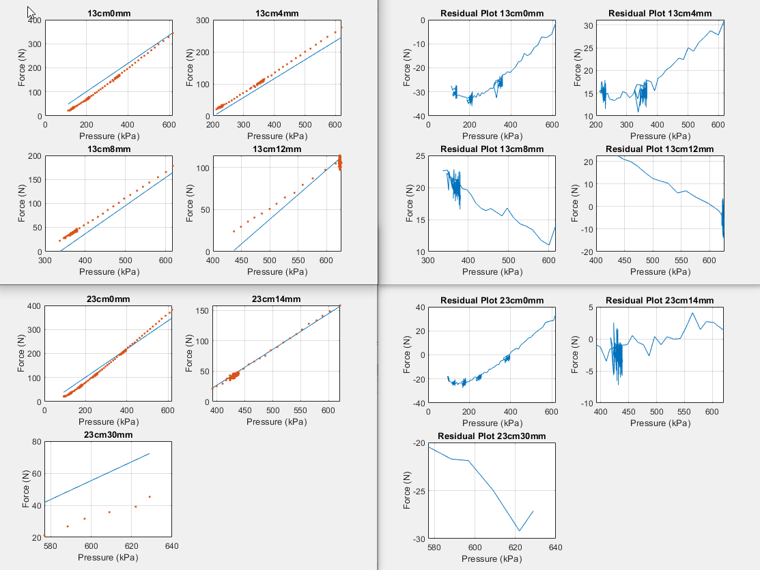**10mm (Depressurizing)**

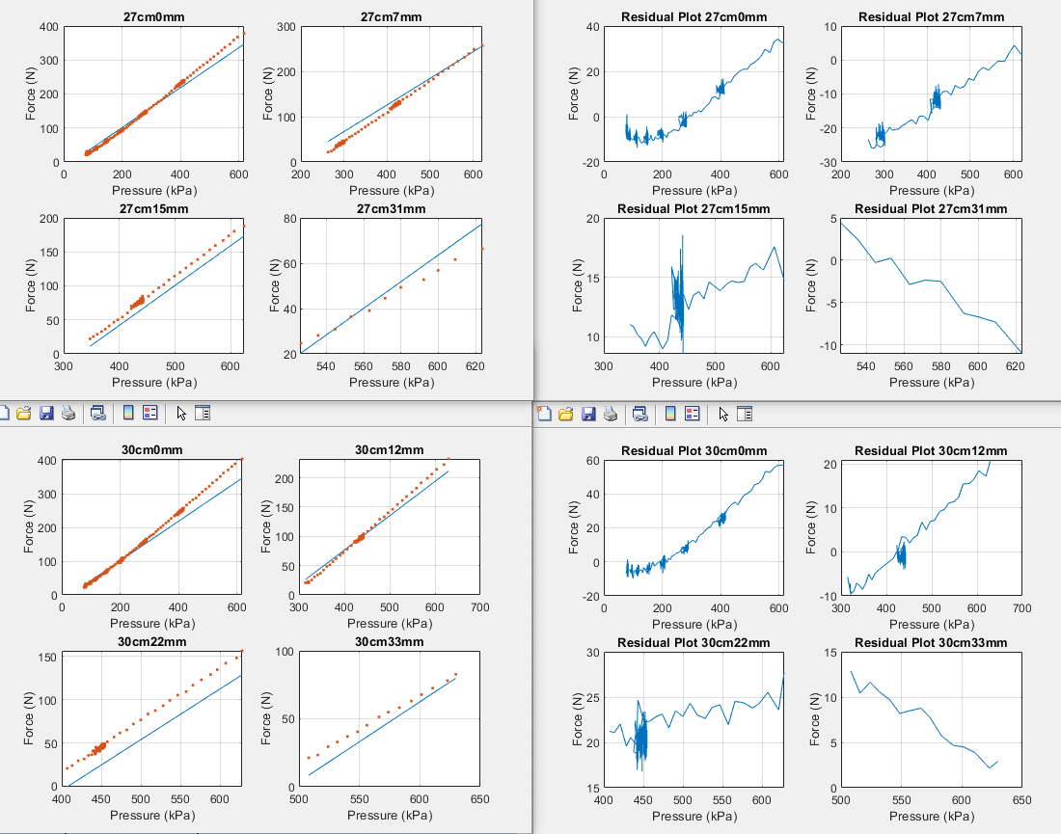

**20mm (Pressurizing)**

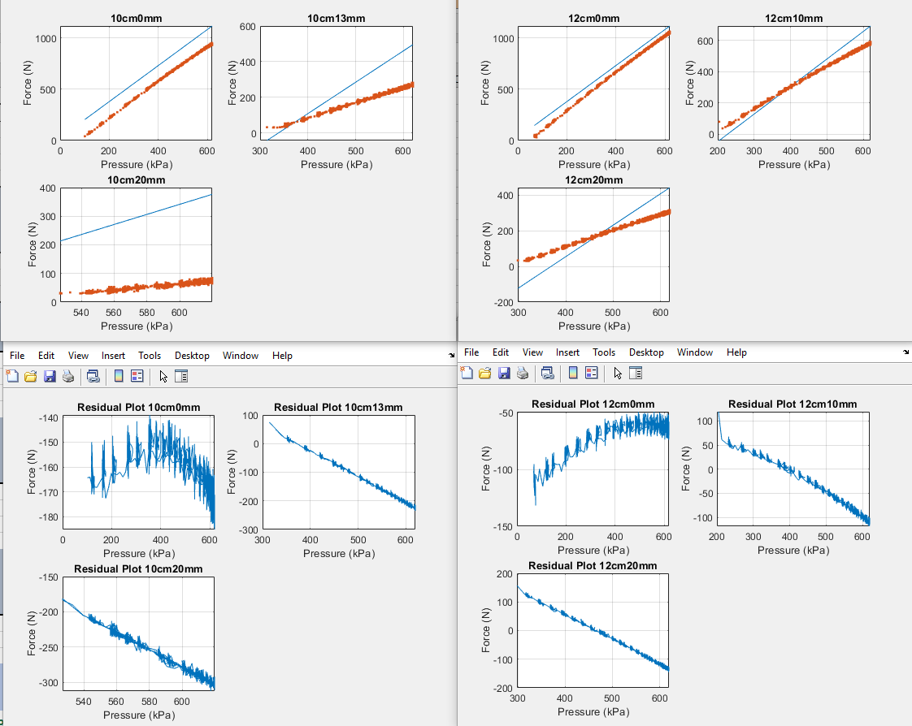

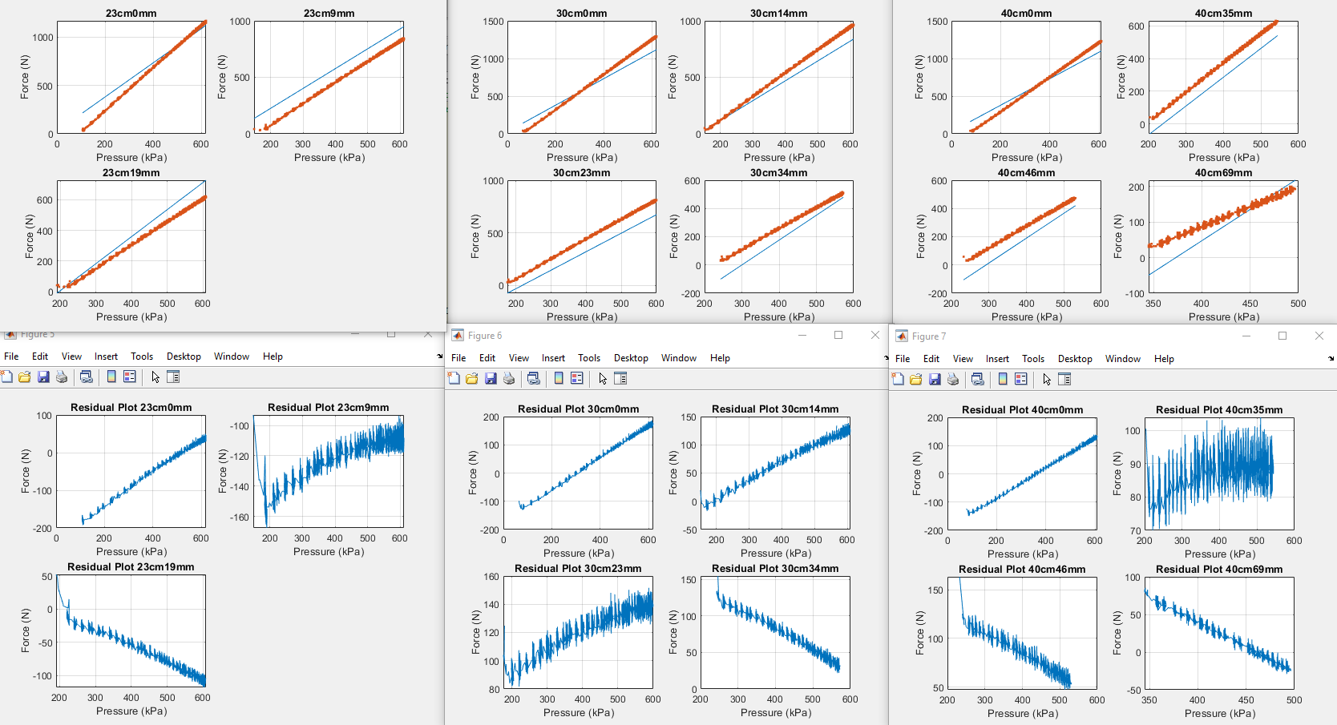

**20mm (Depressurizing)**

